SWITZERLAND

Switzerland has something special for you whether your idea of the perfect vacation is hiking in a world of breathtaking vistas or pampering yourself in the lap of luxury.
It is best known for its financial institutions, fine cheese and chocolate, watch making industry, for its scenery and an excellent network of public traffic.
The fusion of German, French and Italian ingredients has formed a robust national culture, and the country's Alpine landscapes have enough zing to reinvigorate the most jaded traveller. Goethe summed up Switzerland succinctly as a combination of 'the colossal and the well-ordered'. The untamed majesty of the Alps and the tidy, just-so precision of Swiss towns prevent Switzerland from ever being as one-dimensional as some pundits like to try and make it.

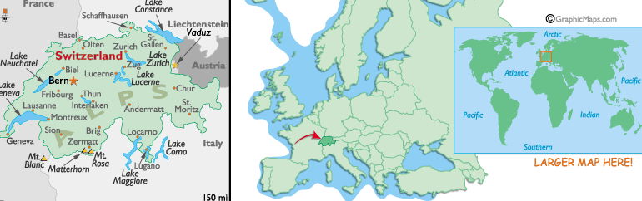

VISA The visa is to be obtained prior to arrival in the country

CAPITAL:
Bern

GETTING THERE:
Switzerland is a small multi-cultural, multi-lingual country located in the very heart of Europe. It shares common frontiers with five countries - Germany, France, Italy, Austria and the tiny Principality of Liechtenstein. Switzerland is therefore at the crossroads of the continent. It is a focal point of international air, road and rail traffic and easily accessible within hours from major European cities and centres.
By Air: Swiss International Air Lines is the national carrier of Switzerland serving 70 worldwide destinations in 42 countries from its home hub in Zurich, and from Basel and Geneva international airports.
Zurich and Geneva airports are fully integrated into the Swiss railroad network and have their own railway stations.
By Train:
Thanks to its convenient central location, Switzerland is also served by fast reliable inter-European rail services from at least a dozen countries. Daily services operate from major cities in Germany, Italy, Austria, Spain, France, the Czech Republic, Hungary, Scandinavia, and the Benelux countries. Most trains include dining cars, bars and a wide range of other amenities and - for night travel - comfortable sleeping compartments

LANGUAGE:
German is spoken (North, Central, and Eastern Switzerland) by 64 %,
French is spoken (Western Switzerland) by 20 %,
Italian is spoken (Southern Switzerland) by 7 %,
Romansch and English is widely spoken too.

CURRENCY:
The currency is Swiss Franc (CHF).
Costs are higher in Switzerland than anywhere else in Europe. All major travellers' cheques and credit cards are accepted. Commission is not charged for changing cash or cheques, but shop around for the best rates (hotels usually have the worst rates).

TIPPING:
Tipping is rarely necessary as hotels, restaurants and bars are required by law to include a 15% service charge. Even taxi fares normally have a service charge included.

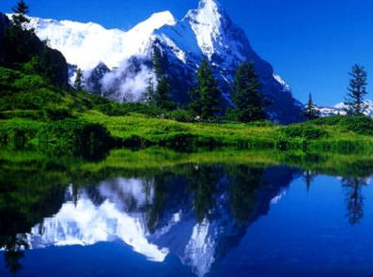

REGIONS:
Zurich
Bernese Oberland: Bern, Gstaad, Grindelwald, Kandersteg, Murren, Wengen
N.E Switzerland: St.Gallen, Rhine Falls
Basel & Jura
The Valais: Matterhorn, Great St.Bernard Pass, Zermatt
Lausanne & the Shores of Lake Geneva
Geneva
Lucerne & Central Switzerlnad: Lucerne, Uri, Unterwalden, Schwyz
The Grisons & the Engadine: Chur, Klosters, Davos & St.Moritz
Ticino: Lugano & Locarno

CLIMATE:
The climate is moderate without excessive heat, cold, or humidity. From July to August the daytime temperature range is 18 to 28 °C (65° - 82° F) and from January to February the temperature range is -2 to 7 °C (28° - 45° F). In spring and autumn, the daytime temperature range is 8 to 15 °C (46° - 59° F). Depending on the altitude, the temperatures may vary.
You can visit Switzerland any time throughout the year. Summer lasts roughly from June to September, and offers the most pleasant climate for outdoor pursuits. Unfortunately, you will not be the only tourist during this period, so prices can be high, accommodation hard to find and the mainstream sights crowded. You will find much better deals and fewer crowds in the shoulder seasons of April-May and late-September-October.
If you are keen on winter sports, resorts in the Alps begin operating in late-November, move into full swing around Christmas, and close down when the snow begins to melt in April.

It is highly recommended for visitors to pack a sweater, good walking shoes, sunscreen, sunglasses, a compact umbrella, and/or a light raincoat.

VOLTAGE:
The electrical current is 110/ 220 volts, AC 50Hz.

SECURITY, HEALTH AND INSURANCE:
Switzerland has one of the lowest crime rates of all industrialized countries. However, it is always wise to keep an eye on wallets and luggage in busy areas.
Drinking and eating-out is hygienic and the tap water is safe.
Personal travel insurance is strongly recommended, including coverage of personal accident, sickness, loss or damage to luggage and personal effects.
GETTING AROUND:
Switzerland has a fully integrated and comprehensive public transport system incorporating trains, buses, boats, funiculars and cable cars. Internal flights are not of great interest to the visitor, owing to the excellent ground transportation.
The Swiss rail network covers 5000km. Trains are clean, reliable and frequent.
Yellow post buses supplement the rail network and their stations are next to railway stations. There are car-rental agencies in most sizeable towns. Roads are well maintained, well signposted and generally not too congested, though you may find it hard to concentrate with such wonderful scenery unfolding around you. Bicycles can be hired from most railway stations and returned to any station with a rental office. All the larger lakes are serviced by steamers, and rail passes are valid on most steamer routes.
-Swiss Travel System Network
-Swiss Pass
-Intercity trains
-Regional trains
-Mountain trains
-Boats
-Postal buses

EVENTS:
February is carnival time, or Fasnacht, in many towns, but Basel really funks it up with elaborate parades beginning at a bleary 4 am. In the lower Valais, from March to October, cows battle it out in the Combat de Reines (cow fighting) to see which beast is most suited to lead the herd up to the summer pastures. The world-renowned Montreux Jazz Festival takes place in July. National Day (August 1) is celebrated with fireworks throughout the country, and Swiss wrestling in the Emmenthal area east of Bern. On the fourth Monday in November, Bern hosts its famous onion market (Zibelmarit), where traders take over the whole town centre and many a tear is shed.

CITIES:

ZURICH:
Getting There:
By Air : Kloten Airport (11 kms from city)
Getting to the city: Train to Zurich Hauptbahnhof (15 mins)
Train : Trains leave from Gare de l’Est in Paris and Munich.

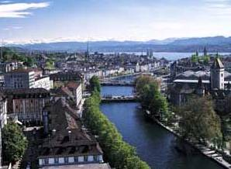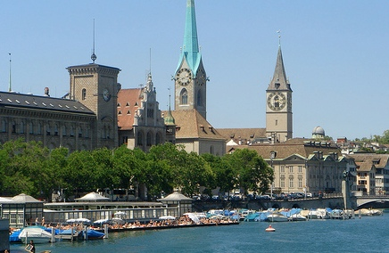

Zürich offers gentle hills, peaceful woods, unpolluted lakes and rivers, picturesque villages - and all this, just a stone's throw from the Alps. Zürich is the ideal starting point for all kinds of varied excursions. The city is situated some 400m above sea level, straddling the Limmat River as it leaves the northern end of Lake Zurich. The pedestrian streets of the old town contain most of the major sights, including winding alleyways, 16th- and 17th-century houses, guildhalls and courtyards, and rather a lot of fountains Enjoy the pretty Old Town, the trendy new Zürich West district and the glorious Zürichsee ( Lake of Zürich). With opera, ballet, theatre premieres, shows, musicals, art exhibitions in over 50 museums and 100 galleries, time never drags in Zürich. The famous Bahnhofstrasse and the Limmatquai are a shopper's paradise.
For the clock-watchers, the 13th-century tower of St Peter's Church has the largest clock face in Europe. The Fraumünster Church nearby is noted for the distinctive stained-glass windows in the choir.
The Museum of Fine Arts has a large permanent collection ranging from 15th-century religious art to the 'modern' art of Monet, Manet and Man Ray. The Swiss National Museum, housed in a pseudo-castle north of the city centre, provides the ultimate rundown on the life and times of the Swiss nation. When the culture vulture in you can't take any more, there are pleasant pathways along the shores of Lake Zurich that pass picnic, sunbathing and swimming spots.
Thanks to the train system Zürich is a good spot to start and end your trip through Switzerland. All the major cities are reachable within 3 hours.

LUZERN (LUCERNE):
Getting There:
Lucerne lies at the junction of four major rail lines, which connect it by fast train with every other major city of Switzerland.
Travel time from Bern is 90 minutes;
From Zurich, 50 minutes.

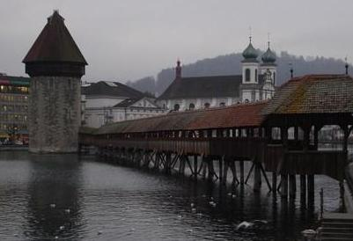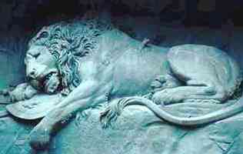

Luzern is ideally situated in the centre of Switzerland. It reflects the 'true' image of Switzerland, with its picturesque mountains, lakes, cowbells, and alpine villages.
Luzern is famous for its covered bridge called Kapellbrücke, which stretches over the Reuss River
A steamboat ride may be taken around the Vierwaldstattersee (Lake Lucerne) or one can take a ride on the mountain railways that lift up high, to one of the surrounding pre-alpine summits like Pilatus, Bürgenstock, Stanserhorn and Rigi surrounding Luzern, there are plenty of breath-taking views all around.
On the north bank of the Reuss, the picturesque old-town centre offers 15th-century buildings with painted facades, towers, a 17th-century Renaissance Town Hall and a couple of postcard-perfect covered bridges. North-east of the city centre is the poignant Lion Monument, which was carved out of natural rock in 1820 and is dedicated to the Swiss soldiers who died in the French Revolution. Next to, it is the fascinating Gletschergarten (Glacier Garden) where giant glacial potholes prove that 20 million years ago Lucerne was a subtropical Palm Beach.
The Transport Museum contains trains, planes, and automobiles and includes the “Swissorama”, a 20-minute, 360° film that whizzes you around the sights of Switzerland as if you were travelling by air, sea, road and foot. If you need some fresh air and exercise to work off all those yummy chocolates you've been scoffing, paddleboats, rowboats and kayaks can be hired on the Reuss River and on Lake Lucerne.

Excursions from Lucerne:

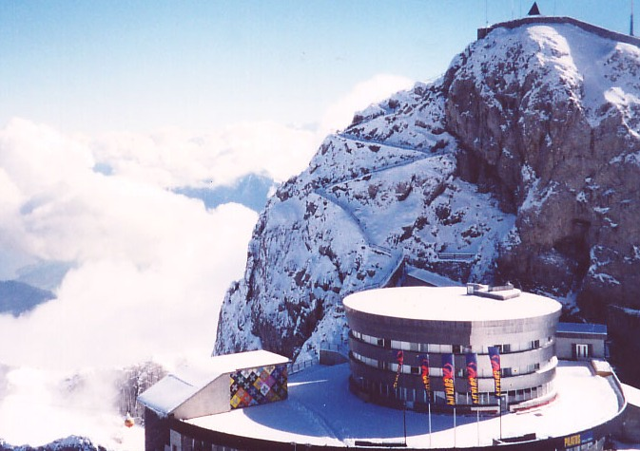

Mt Pilatus:
The world's steepest cogwheel railway, The highlight of the tour is the magnificent view from 7,000 feet above sea level. At the summit, you will see over 70 peaks and five different lakes. The world’s steepest cogwheel railway operates from May to November (depending on snow conditions). However you can still visit the top of Mt. Pilatus via the panoramic gondolas and the aerial cable cars that continuously operate from Kriens to Pilatus Kulm during the entire winter.

ENGELBERG:
Engelberg is a summer as well as a winter holiday paradise at 1050 m (3440 ft) above sea level. The village radiates the special charm of the Benedictine monastery, the wonderfully fresh countryside and an impressive mountain panorama. One can take a ride in the numerous Cable Cars or enjoy a meal at one of the good restaurants. Mountain huts and hotels providing
scenic views, guarantee a memorable stay.
There are also plenty of wellness programs to choose from in order to relax your mind and body.
In the summer you can enjoy a breathtaking view over the snow-covered mountaintops of central Switzerland, on Mt. Titlis. From the 2000 m (6560 ft) height Mt Titlis is a 12 km descent.

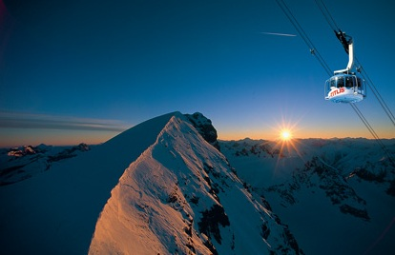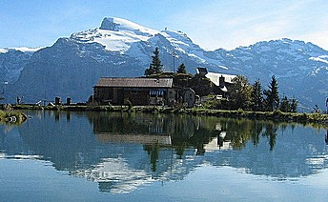

For more adventurous visitors, there is the possibility of a bungee jump from a cable car or a lively river rafting trip on the wild and romantic River Aa in Engelberg.
In the evenings, do not forget to check out the cozy restaurants and bars. In the winter, the Engelberg Mountains offer a lot of fun. This applies to the slopes just as much as to the
nightlife. At Engelberg, with over 20 railways and ski lifts, this is the ideal terrain for every adventure seeker.

Excursion from Engelberg:
Mount Titlis:
This glacier paradise at 10,000 feet offers a snow and ice experience on the highest viewpoint in Central Switzerland. Only 40 minutes by train from Lucerne. The Mt Titlis ticket entitles you to round trip travel from Engelberg to Mount Titlis, a summer snow paradise in Central Switzerland with the world's first revolving cablecar. A series of three cable cars snake their way up the mountain, climbing from green Swiss meadows on the valley floor to the permanently frozen glacial peak. On the final leg the "RotAir" cable cars rotate a full 360 degrees in their five-minute climb up to the summit station at 3,020m (10,000ft) giving each passenger a panoramic view of some of the most beautiful mountain scenery in Europe.Ride the Ice Flyer, a chairlift that spans the glacier crevasses of Mount Titlis, or take to a snow tube down a 500-ft. slide called the Fun Lift.
Hiking around the green fields of Lake Trubsee and enjoying the Trotti-Bike (scooter) ride while descending the mountain will round out your trip back to the village of Engelberg.

Titlis is the only summer snow paradise to be reached within 1 ½ hours from Lucerne, Zurich, Basel and Berne. Clients can take advantages of the slopes all year round. Even in the summer, there are several downhill runs for skiers, a fun park for snowboarders, an aerial lift, guided glacier walks, and much more.

INTERLAKEN:
Getting There:
There are several trains daily between Zurich and Interlaken (2 hr.) and between Bern and Interlaken (40 min.). Frequent train service also connects Geneva with Interlaken (2 1/2 hr.). Interlaken East and Interlaken West, West is most convenient to the city’s center.
Interlaken lies between Lake Thun (foreground) and Lake Brienz in the Bernese Oberland.

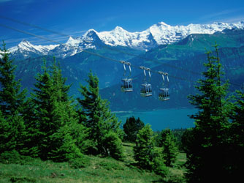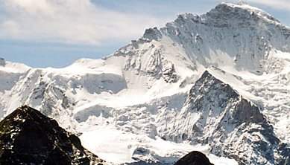

Interlaken is the centre of the Bernese Oberland, holding a prominent position among Europe's tourist resorts. Come and experience an unforgettable holiday in an extraordinary region between the lakes of Thun and Brienz, at the foot of the imposing threesome, Eiger, Mönch and Jungfrau Mountains. Explore the remaining mysteries in the Mystery Park.

Must Sees:
Boat Cruises on Lake Thun & Brienz

Excursions:
Schilthorn:
As the longest aerial cableway in the Alps, the Schilthorn/Piz Gloria provides the most unimpeded panoramic views in Switzerland. Over 200 mountain peaks in a spectacular landscape are revealed as the world's first revolving mountaintop restaurant slowly turns. From the top of the Schilthorn, at almost 9,842 ft (3,000 meters) altitude, you can admire Switzerland's most breathtaking 360º alpine panorama.

Schynige Platte with Alpine Garden:
As the first of only a few botanical gardens in the Alps, the Alpine Garden at Schynige Platte is truly exceptional. It shows the plants as they would be found in their natural environments above the Swiss forest frontier. One can find the entire richness of the Swiss alpine flora (about 600 species) displayed at the Gardens. The biggest part of the area is covered by the blue moor-grass meadow, the Rosteggenhalde and the sea milk wort meadow.

Mystery Park
Enjoy the most enchanting riddles and piquing multimedia presentations that excite and educate you during your tours to Mystery Park in Interlaken, Switzerland. Mystery Park Tours with Switzerland Flexi Tours will transport you into a wonder world where you delve deep into the unsolved mysteries of the EarthTheme park.

The seven pavilions are:
Challenge - that delves into the concept of outer space and visits to Mars
Vimana - tries to figure out the reality behind the "flying vehicles" mentioned in the great Indian epics, Mahabharata and Ramayana.
Nazca - delves into the secret of Nazca lines close to Peru
Orient - discusses the mysteries related to the Pyramid at Giza
Mega Stones - tries to solve the mysteries related to the Stone Age.
Contact - explores the concept of cargo cults.
Maya - is an effort at finding out more about the Mayan calendar.
Ballenberg : Open Air Museum
Firstbahnen Grindelwald
This aerial cableway uses small gondolas to transport hikers and tourists up the mountainside. You will enjoy spectacular views on the ride up and from the upper station, where you can have a meal or snack before hiking or riding back down.
Beatenberg
On a mountainside just minutes from Interlaken, you will find an unspoiled paradise for hikers and skiers. One can do Tandem Paragliding in all the seasons.

Jungfrau region:
If you're looking for jaw-dropping scenery, the Jungfrau region south of Interlaken has it in spades. The towering 4000m triplets - the Jungfrau, Mönch and Eiger - dominate the area, and there are plenty of cable cars, funiculars, cog-wheel railways and hiking trails offering panoramic vantage points for those not suffering landscape vertigo. Grindelwald is the most established skiing and hiking centre in the region; watch out for the yodelling festival held here in July

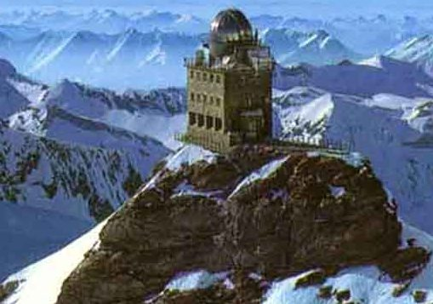

GENEVA:
Getting There
Air: Geneva-Cointrin airport
Getting to the city: Train (7 mins)
Train: Geneva’s CFF (Chemins de Fer Fédéraux) train station in the town center is Gare Cornavin, place Cornavin
Ferry: Daily arrivals by Swiss lake steamer year-round from Montreux, Vevey, and Lausanne

Geneva is set on the banks of Lake of Geneva and the city looks out onto the snow-capped peaks of the Alps and Jura mountains jutting out of the deep forests and mystical countryside
This spic-and-span city belongs to the international community as much as it belongs to the Swiss: over 200 international organisations are headquartered here; Geneva is a very mesmerizing city. People from many nations are living together in the city making it a cosmopolitan in its own right
The city enjoys a fine location, and strolls around the lake and boating excursions are hugely enjoyable. The cable car up Mont Salève offers the complete picturesque panorama. The Rhône River runs through the city with the old part of town lying on the south side. The centre of town is dominated by the partially Romanesque, partially Gothic Cathedral St Pierre. The nearby Place du Bourg-de-Four is the oldest square in Geneva.
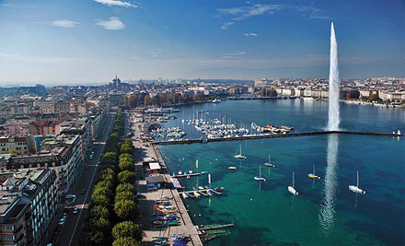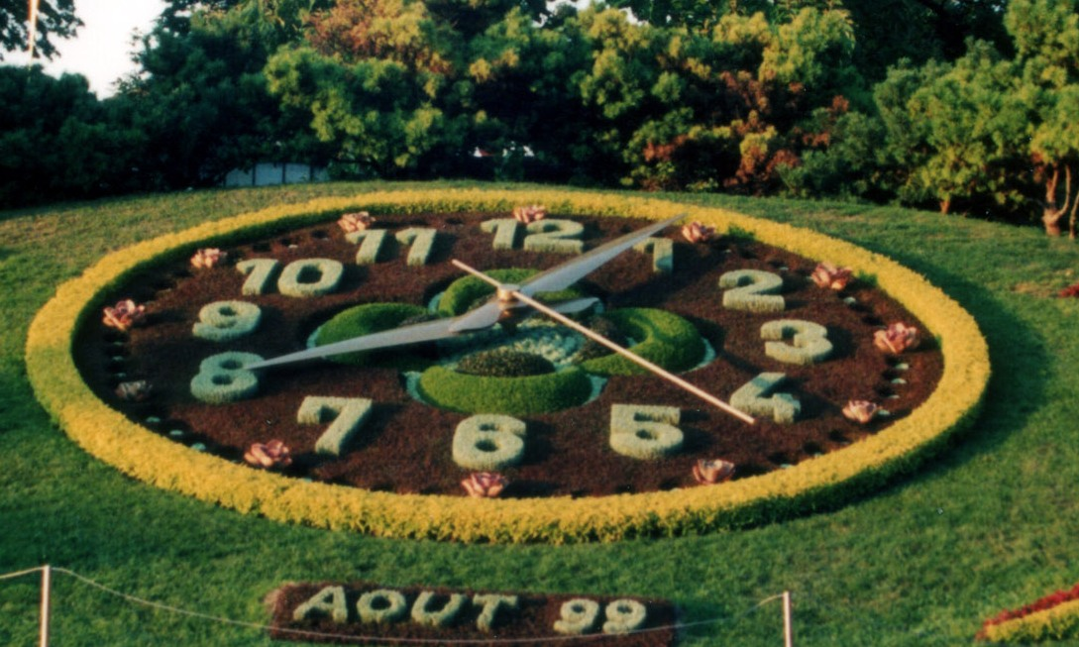
The city also includes the Jet d'Eau, a 400-foot geyser. A cruise on the lake of Geneva provides a beautiful view of the highest mountain in Europe, the Mont Blanc.

Fortunately, there is plenty of culture to combat the kitsch. The Museum of Art & History has a vast and varied collection including paintings, sculpture, weapons and archaeology. The compact Petit Palais has an excellent and focussed collection of modern art. The International Red Cross & Red Crescent Museum offers a vivid multimedia trawl through atrocities perpetuated by humanity in recent history. Other museums include the catchy Museum of Old Musical Instruments, the Horology Museum and the Voltaire Museum.

Jet-set style seeps from the shores of the lake thanks to the romantic walk lined with numerous shops, restaurants, and hotels. Geneva offers over 1,100 restaurants to get your taste buds tingling.
Geneva has decent nightlife, but it is not cheap. The presence of so many diplomats, international administrators, and bankers also means that prices for food and accommodation can be high. A handful of hostels and budget hotels can be found on both sides of the river. Inexpensive restaurants are concentrated in the vicinity of the university and north and west of Gare de Cornavin.

Must Sees:
Jet d’eau (Water Fountain)
Flower Clock
United Nations Building
Carouge
Cruises on Lake Geneva

CHÂTEAU DE CHILLON:
Chillon Castle receives more visitors than any other historical building in Switzerland. Occupying a stunning position right on Lake Geneva, the fortress caught the public imagination when Lord Byron wrote about the fate of Bonivard, a follower of the Reformation who was chained to the fifth pillar in the dungeons for four years in the 16th century. Byron etched his own name on the third pillar. The castle, still in excellent condition, dates from the 11th century and has been much modified and enlarged since then. Its worth spending an afternoon viewing the tower, courtyards, dungeons and numerous rooms containing weapons, utensils, frescos and Tupperware. The castle is located within walking distance of Montreux, the centrepiece of the Swiss Riviera.

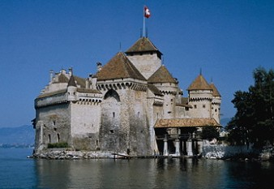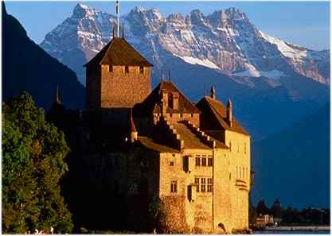

ZERMATT:
Zermatt is located at an altitude of 1620 m (5310 ft) above sea-level in the south-west of Switzerland. This car-free, idyllic village in the Matter Valley in the canton of the Valais, nestles amongst fabulous scenery of mountains and glaciers offers visitors a fantastic panorama of 38 peaks. This swanky skiing and mountaineering resort bathes in the reflected glory of one of the most famous peaks in the Alps, the 4478m Matterhorn. Skiers come here to enjoy virtually year-round skiing and there are 230km of runs in the area, catering mainly to intermediate and experienced skiers
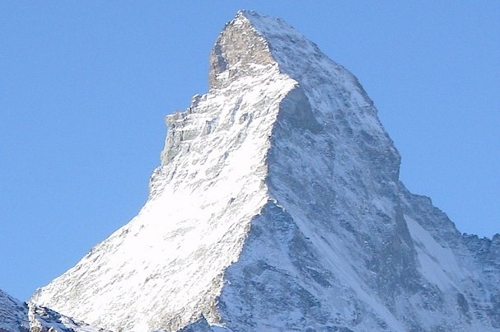

For some magical vistas of the Matterhorn and surrounding peaks, take the popular cog-wheel railway to Gornergrat. It's easy to get around Zermatt on foot (the town is car-free) and it's well worth exploring the Hinter Dorf area, which is crammed with traditional tumble-down wooden Valais homes.
Zermatt is a great place to explore on foot as it is car free, one can comfortably move around by foot.
From the Gornergrad, stunning views of the Matterhorn and the surrounding mountain summits can be enjoyed.
The Klein Matterhorn is the highest cable car station in Europe.

Bern
Getting There
Air: Bern-Belp airport (10 kms from city)
Getting to the city: Shuttle bus to Bahnhof station
Train: Direct connections with France, Italy, Germany, Benelux, Scandinavia, Spain.
TGV from Paris – 4.5 hrs
Geneva: 90 mins, Zurich (75 mins)
The capital of Switzerland, Bern, is a charming blend of the modern and the traditional. This UNESCO recognized Heritage city, boasts of tall church spires and 18th century mansions that jostle for space with spanking new exhibition centres, Grand Prix racetracks, and pubs.
One of the most distinguished citizens of Bern has been Albert Einstein. Visit the Einstein House and the Historical Museum of Bern to know more about the man known as the "Greatest Mind of the 20th century".
It has one of the longest covered shopping malls in Europe with 6km of arcades.
Unique landmarks: The Zytglogge (Clock Tower), Bear Pit, Parliament Building, Cathedral, etc. The Collection of Classical Antiquities displays fascinating artifacts from the Greek, Roman and Egyptian Empires of the ancient world.
When it comes to Museums and Theaters, Bern relegates competitors to the background. The Bern Art Gallery, inaugurated in 1918, is a symbol of Bernese cultural accomplishments.
Bern is also an eclectic city when it comes to cuisine. You can eat out at any of the myriad restaurants, cafes and eating outlets dotting the city.
Must Sees:
Bear Pits & Park
City of Fountains
Clock Tower
House & Square of Parliament
Kafigturm (Prison Tower)

Excursions
Montreux – Vevey
Lausanne

MONTREUX-VEVEY
Montreux is one of the most beautiful Swiss cities situated on the banks of Lake Geneva. Montreux is associated with the world famous Jazz Festival that is held every July in this dynamic city. In fact the city can be called a giant open-air music theater. Every street has a music club or a theatre. In addition, the charm of the castles and vineyards of the surrounding region will mesmerize you, and you will begin to understand why Montreux is called the "Swiss Riviera".

LAUSANNE:
Lausanne is the city of culture, arts and festivals. It is one of the most eclectic cities in Switzerland, pulsating with life and dancing to the rhythm of a dozen different dance and music festivals that are held here at any given time. Photography, movies, modern art - Lausanne has them all. Explore the museums and theaters of Lausanne, the greatest testament to the culture and vibrancy of the city. The opera, theater, and dance performances are among the biggest cultural draws of this city. The city is also famous for its music festivals
and cinema festivals. Lausanne is also the city of museums.

LUGANO:
Lugano is not only the third Swiss financial market, congress, banking and business centre but also the city of parks and flowers, of villas and sacred buildings. With its Mediterranean flair, characterized by the joie de vivre typical of countries of the South, Lugano offers all the advantages of a big city together with the charm of a country town.
Its fame as a cultural centre is due to the extremely high level of important exhibits that are regularly organized in the different museums of the city and region.

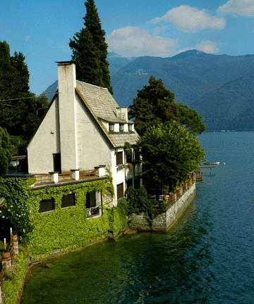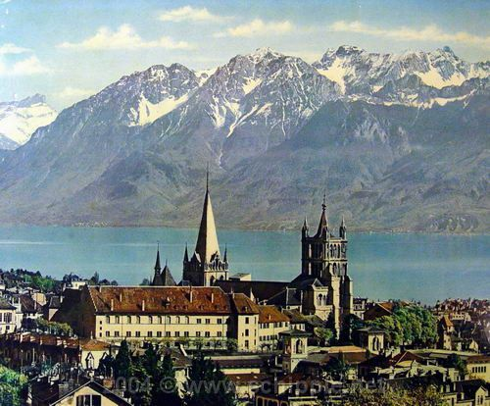

ST. MORITZ:
St. Moritz, a famous exclusive holidays resort with its "dry-, sparkling champagne climate" and its very cosmopolitan ambience, is nestled 1,828 m (6,000 ft) high in the Swiss Alps. The renowned St. Moritz sun shines an average of 322 days a year - more than anywhere else in Switzerland! This world famous resort is resplendent in its picturesque surroundings on the edge of a pristine mountain lake. It offers the appealing combination of an unspoiled natural environment, cultural activities, sports possibilities, attractive facilities, great shopping and a relaxing atmosphere.
The name 'St. Moritz' is today a synonym worldwide for 'chic, elegance and class'! The name stands for style, tradition and quality and its success proves that: St. Moritz keeps its promise!

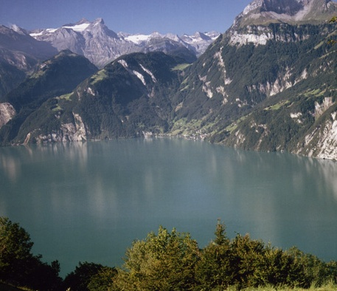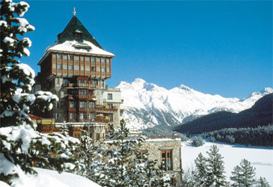

BERNESE OBERLAND:
For some great castle-touring head to the Lake Thun area in central Switzerland, just south of Bern. In the town of Thun itself, you'll find the 12th-century Schloss Thun on the hill. It contains a good historical museum and there are fine views from the turrets of the Romanesque tower. One of the best castles around the lake is the 13th-century Schloss Oberhofen, which was once held by the Habsburgs, and has a good collection of grand furniture, portraits and weapons, and even boasts a Turkish smoking room. The gardens were landscaped in the 19th century and are a fine place for a stroll. Schloss Hunegg at nearby Hilterfingen was built in the 1860s and renovated in 1900. It's a fascinating mix of neo-Renaissance and art nouveau styles and has a funky split-level bathroom complete with a nickel-plated bathtub. If you're a castle buff, you can squeeze in a visit to all three fortifications in a day-trip by boat.

Indian Restaurants in Switzerland:
Zurich
Maharani
Limmattalerstrasse 252, Ecke Wartauweg 18,
8049 Zürich-Höngg, Switzerland.
Tel: 043 300 45 55 Fax: 043 300 45 56

Restaurant Kerala
Hofwiesenstrasse 188, 8057 Zürich,
Switzerland, 01 364 45 77. Tel: 01 364 45 77.(Monday closed)

Khan’s
Marktgasse 17 8001 Zurich

Taste of Paradise
Löwenstrasse 35 (Migros City, 1st floor)
8001 Zurich

Thamilini
Martastrasse 145 8003 Zurich

Masala
Stauffacherstrasse 27 8004 Zurich

Raja Bongo
Zwinglistrasse 3 8004 Zurich

King’s Kurry
Freyastrasse 3 8004 Zurich

Vulkan
Klingenstrasse 33 8005 Zurich

Taj Palace
Hönggerstrasse 25 8037 Zurich

Taj Palace Schützenburg
Üetlibergstrasse 354 8045 Zurich

Spice Route
Badenerstrasse 505 8048 Zurich

Handi
Schwamendingenstrasse 16 8050 Zurich

Indian Palace
Schaffhauserstrasse 129 8057 Zurich
LUCERNE
Gourmet India
Baselstrasse 80
Luzern
Switzerland

Taj Palace
Löwengraben 18
Luzern
6004
Switzerland
410 70 20

Kanchi
near the lion monument Zürichstr. 4 / Friedenstr. 2, CH-6004
Luzern
Switzerland
041 410 6708

Tandoori Indian
Kantonsstrassae 74 / 6048 Horw
Luzern
Switzerland
340 52 96

INTERLAKEN

Spice Indian
Postgasse 6
Interlaken
Bern
3800,Switzerland
033 821 0091

Welcome India
Rosenstrasse 7
Interlaken
Bern 3800
Switzerland

SHOPPING IN SWITZERLAND:
Shopping in Switzerland is pure joy. Whether you wish to rummage through flea markets, look at colorful markets, or comb through luxury goods boutiques, you will not be disappointed. Of course, you will encounter all the world's well-known brands but above all, don't miss out on Swiss designers.
Whether you are looking for the ultimate Swiss Army knife, a classical watch or an extravagant piece of jewellery - or maybe just some chocolate and cheese, you will find it in Switzerland.
Bern: Shopping Beneath the Eaves
For the ultimate romantic experience, shop in Bern's historical center, in centuries-old buildings where luxury boutiques are cheek-to-jowl with more common-place bakeries and butcher shops. Because pedestrians walk under covered eaves, this is as enjoyable an experience in rain as in sunshine.
Zurich: Bahnhofstrasse, Rennweg
Dawdle in front of well-executed shop windows, enjoy a coffee there, watch the world go by, and of course, shop to your heart's content: Zurich's Bahnhofstrasse has long had the
reputation for being one of the world's premiere shopping venues. Whether you are looking
for watches, chocolate, accessories, fashion, or antiques, you will find it here or close by. Of course, one of the most prominent stores on Bahnhofstrasse is Bucherer, a wonderful place to find top-notch watches and jewellery. For persons looking for the perfect bring-along, check out the Heimatwerk (Rudolf-Brun Bridge, www.heimatwerk.ch or in the Main Train Station).
Geneva
Shopping in Geneva is a joy: whether you stroll through the Rue Basses with its hip little boutiques or the chic Rue du Rhone, Rue de la Confédération, Rue du Marché, Rue de la Croix-d'Or and Rue du Mont-Blanc.
Lugano: Piazza Riforma / Via Nassa
Shopping with an Italian flavor: stroll through Italienate piazzas and the Via Nassa, where all the world's major brands meet. Even stylish people from Milan come and shop here!
Luzern
Tradition and modernity goes hand in hand in this lovely town on Lake Luzern. And be sure to pop in at Bucherer's. The well-known watch and jewellery store has its headquarters, ore than 4000 watch models and pieces of jewellery, ranging from the functional to the extravagant.
NIGHTLIFE:
Over 1,700 restaurants and bars serve both traditional Swiss dishes as well as exotic specialties. The evenings will leave you with unlimited choices: indoors or outdoors; anything is possible as far as the nightlife in Zürich goes. Zurich by night offers a world of cozy pubs, dance clubs, lively bars and jazz clubs!! For culture lovers, there is ample variety of live theaters, dances, opera and classical music concerts.

